Video Games – Culture and Industry

MCC-UE 1008-002 William Lockett (wjl285@nyu.edu)
Rogers Hall RGSH_325 2 MetroTech Center, 8th floor commons
Fridays 12:30 – 3:00pm Office Hours: Fridays 4:00 – 5:00

Course Description

From the course catalogue:

The course examines the emergence of video games as a site of contemporary cultural production and practice. It pays special attention to the symbolic and aesthetic dimensions of video games, including their various narrative forms and sub-genres, and concentrates on their interactive dimensions. The course provides insight into the emerging trends in the interface between humans and media technologies. The course also situates video games within the business practices of the entertainment industries.

Video and computer games have a rich historical record. In the late 1950s, computer scientists used their mathematical analyses of puzzles and board games to make computers that could interact with symbolic languages (instead of operating exclusively with numbers and signals). In the 1960s, academic computer labs, with funding from the American military, offered university students and faculty access to general purpose programmable computers. Computer clubs hosted afterhours programming sessions; their members wrote the first games for people on computers, rather than chess playing computer programs. By the early 1970s, such games were part of the computer programming communities that gave us the graphical user interface, the mouse, and a set of standard applications: word processors, spreadsheets, online messaging, and file sharing.
Video and computer games are big business. Video games were the first wave of mass market electronic games: not necessarily computers, the arcade cabinets and home consoles of the 1980s showed American and Japanese corporations that the domestic use of video technology—i.e. television—was not restricted to broadcast and cinematic media. But by 1977, and decisively by 1983, the arcade and home console market crashed. Even before the crash, computer users—working with early personal computers—made games that departed from the arcade style ported to the consoles. While the commercial market for video games slumped, these home computer users worked collaboratively to invent text adventure games. Throughout the 1990s and early 2000s, computer games shaped the mobile electronics market, the early internet, liberal moral panics, and the business models of major software development corporations. The academic world of the 1960s had planted the seed for a multi-billion-dollar global industry that has surpassed even the scale of twentieth-century entertainment media.
Video and computer games are a cultural phenomenon. The hacker ethos of the academic computer lab and the amateur home computer user mutated and spread as programmers built new tools and education platforms to support the games industry or realize their eccentric personal proclivities. As the means of production opened up to a wider base of designers and programmers, politicized agents took up games as a site of protest.

Readings

All course readings will be provided on NYU Classes as .pdf files found in the Resources folder. If students wish to purchase copies of desirable course books, they are encouraged to do so.

Learning Outcomes

Students will learn to:

- Identify and describe video and computer games with language beyond folk periodization, genre norms, and marketing nomenclature by using terminology from the history of computers, media studies, game studies, and popular games print culture.
- Perform primary source research on video and computer games using emulators, online collections of print material, archived internet content, and industry data.
- Demonstrate familiarity with major facets of the contemporary culture and industry of video games: including games journalism, production practice (corporate, independent, and artistic), and styles of use (casual, hardcore, and critical).
- Produce articulate prose that describe, situate, and evaluate video and computer games with reference to persistent topics of cultural, political, and economic significance.

These outcomes, if pursued to their fullest, will prepare you for undergraduate thesis research, graduate school applications, freelance writing, and for personal wayfinding in more specialized subdomains of the games industry.

Evaluation Breakdown

Participation 15%
Reading Responsibility One 5%
Reading Responsibility Two 5%
Mini-assignment (Midterm Prep) 5%
Midterm 20%
Paper Proposal 15%
Mandatory Writing Help 5%
Final Paper 30%

Reading Responsibility One and Two

Each class begins with me opening the floor to the reading respondents. You must take responsibility for two readings, of your choice, from two different weeks—one before the midterm and one after. To take responsibility for a reading, you must first read it carefully; then you decide on an approach to it. Draw your colleagues’ attention to a passage in the text. Ask a question about that passage, connect that passage to another reading or to your personal experiences with games. Or connect it to a story in contemporary popular games criticism. This is not a presentation. No summarizing! Nor is it a personal essay. It is a responsibility that is satisfied by offering a thoughtful and well-informed starting point for class discussion.
Students will sign up for two readings using the reading responsibility either using a link in the main toolbar (left-hand side) on the NYU Classes website or using an excel spreadsheet handed out on the second day of class. They will also submit to me a 1.5-page written document (350 words) by 11:00am the day of class (an hour before class starts). The text need only point me toward a passage that interests you, discuss that passage briefly, and raise some points of discussion, comparison, or questions. This is not a formal academic text; it is a rough text. I recommend that you pick a week that interests you and use your reading responsibility to start digging deeper in your area of specialized interest.

Participation

Participation means coming to class prepared. I will be lecturing for approximately one hour of every class. I will close read the texts and situate them in historical and scholarly contexts. To take advantage of these lectures, you must have easy access to the course readings in the form of a .pdf on a laptop computer or as a print copy. You will need to take notes in class, covering lecture material and reading material, in order to prepare for the exam and the final paper.
Participation is also based on attendance. We only meet once a week. Missing three or four classes amounts to missing a significant portion of the course. I understand that undergraduate life is intense. Please email me if you have reason to miss a class. If you develop a habit of missing class (even with informal excuses) your grade will drop significantly after the 4th absence if no official documentation is provided.

Mini-assignment (Midterm Prep)

Make a mid-term study slide for two of the slides in WEEK 4. (All the slides eligible for the midterm are marked on that week’s slide deck with a green triangle). To get full marks, you will need to identify the item on each slide: name its creator, its title, and its date of production. Then write out four or five complete sentences stating the significance of the slide. To state the significance, would might do one (or any combination) of the following: describe a social, political, or economic context then situate the item within it; name a course author and recount that author’s argument about the item; detail the technical functionality of the item and say why those details are meaningful; describe the stylistic or genre-specific attributes of the item and make a claim about what those aesthetic choices are doing for the expressive potential of games as an artistic medium.

Midterm Exam

The midterm exam is short answer questions. You will be asked to identify, name, date, and state the significance of an image, text, or artifact with reference to course material. You will also be asked to compare and state the significance of two items.
As guidance for your studying, I will provide you with slides that contain all the information necessary to produce the identifications. I will also provide you quotations from course readings that relate directly to the significance of many of the images, texts, and artifacts. The majority of the points awarded for answers will be for stating the significance. You will need to download the lecture slides from NYU Classes and add your own notes to them. By the time of the midterm exam, I will have provided you with a short list of approximately 20 items, two weeks in advance of the exam date, that you will need to memorize and study for the exam. I will also lead an exam review session, with Q&A time, during lecture time the week before the exam. You can draw upon any course readings or lecture slides in your answers. Slides will be distributed after lecture as .pdf files in the Resources folder of the NYU Classes website.

Paper Proposal, Writing Help, and Final Paper

You will produce a 10-to-12-page paper (2500-3000) using original primary and secondary source research. Before thanksgiving, you will begin your project by submitting a 3-to-4-page proposal (750-1000) with an addendum of a bibliography containing six secondary sources and one to three primary sources. You are then required to meet with me for mandatory writing help, in office hours or by appointment, at least once before submitting the paper on the last day of class. You are also invited to meet with me at any point during the semester to identify a topic of potential interest and to brainstorm ideas. I will also provide you with in-class training in the use of online resources that you will need to research video and computer games. You will perform your primary source research using Bobst Library resources, trusted online archival collections, online emulations of video and computer games, and the NYU Tisch Game Center Library. Lectures will include discussions of primary sources that you can use as a starting point for your research. Lectures will provide surveys of secondary literature that you can draw upon as you develop you essay topic.

Paper Formatting (Paper Proposal and Final Paper)

-Academic citation and quotation style throughout
-12-point Times New Roman font
-Double spaced
-Standard margins
-Student’s name, professor’s name, date, course name, and paper title at the top of the first page
-Page numbers in top right-hand corner of each page.

All written assignments must adhere to the New York University, Steinhardt School’s standards of academic integrity. (For details: http://steinhardt.nyu.edu/policies/academic_integrity ). To meet these requirements, you are invited to use consistently any standard academic citation style. (For quick citation help: https://owl.english.purdue.edu/owl/section/2/ )

Grade Scale

A = 95-100% C+ = 77-79%
A- = 90-94% C- = 70-72%
B+ = 87-89% D+ = 67-69%
B = 83-86% D = 63-66%
B- = 80-82% F = 0-62%

Evaluation Rubric
A — The student came to every class or provided a legitimate excuse for any absence. They came to class with the readings prepared in advance. They listened carefully, took notes, and contributed thoughtful questions and comments. On the exam, they provided accurate identifications most of the objects. Their statements of significance were cogent and rich in information. For the final paper, they presented a proposal, with all the appropriate material included, that demonstrated that they had understood course material with sufficient depth to generate a prescient topic with supporting material. The final paper presents a collection of primary and secondary sources that are well organized, accurately presented, and relevant to the deepening of their understanding of video games.

B — The student came to most classes. They came to class with some readings prepared in advance. They listened carefully and took notes. On the exam, they provided some accurate identifications of the items. Their statements of significance were cogent but lacking reference to important material. For the final paper, they presented a proposal, with all the appropriate material included, that demonstrated that they had understood course material with sufficient depth to generate a topic. The final paper was a collection of primary and secondary sources that were well organized and accurately presented but without clearly stated relevance to the histories and theories of video games presented in the course.

C — The student missed four or more classes. They did not demonstrate their engagement with readings in class or in office hours. On the exam, they provided some accurate identifications of the objects but left others unidentified. Their statements of significance were nebulous, scattered collections of course material without clear relevance to the item in question. For the final paper, they presented a proposal, but their bibliography and topic were not clearly connected. The final paper was a collection of primary and secondary sources that did not jell into a cogent story and did not point to any of the core histories and concepts from the course. Little evidence of learning was found.

D — (Course credit will not count toward the MCC major). The student missed four or more classes. They came to class but did not demonstrate their engagement with readings in class or in office hours. On the exam, all their identifications had gaps and their responses were vague and disconnected from the item in question. For the final paper, they presented a proposal that lacked the required number of bibliography items and that stated its topic in terms that could have been formulated without engagement with the course readings and lectures. The final paper presents reading material without capturing any of the content of the course authors’ original arguments and evidence. Exam and assignment could have been written from general knowledge. Little evidence of learning was found.

F — (No course credit). The student missed five or more classes without excuse. They did not demonstrate their engagement with readings in class or in office hours. On the exam, they left questions blank and concocted answers based on general knowledge. For the final paper, they presented a proposal that lacked the required number of bibliography items and that stated its topic in terms that could have been formulated without engagement with the course readings and lectures. The final paper presents reading material without capturing any of the content of the course author’s original argument and evidence. No evidence of learning.
Late Policy

After the deadline, grades drop by 2.5% per day = one step on the letter-grade scale (i.e. from A to A- or B+ to B) every two days. Weekends are not included in the determination of late penalties.

Student Resources

Students with physical or learning disabilities are required to register with the Moses Center for Students with Disabilities, 726 Broadway, 2nd floor (212-998-4980). You are required to present me with a letter from the Moses Center at the beginning of the semester in order to be considered for appropriate accommodation. See details on their website: http://www.nyu.edu/students/communities-and-groups/students-with-disabilities.html

NYU offers students instruction in academic writing via the Writing Center, 411 Lafayette, 4th floor. For more information, and to sign up, see: http://ewp.cas.nyu.edu/object/writing.center

Email Policy

I will respond to all emails within 48 hours. If my office hours do not work for you, or you need extra help, please email me and we can arrange a meeting on Washington Square campus outside of normal office hours. I do not discuss grades or provide evaluations of performance over email but would be happy to discuss such matters in person.

Schedule (at a glance)

WEEK 1 // September 7 // Introductory Lecture //

WEEK 2 // September 14 // Domesticating Vision // [ Crary and Huhtamo ]

WEEK 3 // September 21 // Inventing Usability // [ Turner and Lowood ]

WEEK 4 // September 28 // Video Land // [ Wilson and Bogost ] Mini-assignment

WEEK 5 // October 5 // BBS, MUD, MOO // [ Murray and Brunton ]

WEEK 6 // October 12 // Global-Local Gaming // [ Picard and Steinberg ]

WEEK 7 // October 19 // Midterm Exam

WEEK 8 // October 26 // DOOM and MYST // [ Manovich and Gaboury ]

WEEK 9 // November 2 // Net.Art // [ Galloway ]

WEEK 10 // November 9 // The Media Mix // [ Ito and Nakamura ]

WEEK 11 // November 16 // Edutainment // [ Rankin and Ito ] Paper Proposal

WEEK 12 // November 23 // Thanksgiving, No Class //

WEEK 13 // November 30 // Casual vs. Hardcore // [ Juul and McGlotten ]

WEEK 14 // December 7 // Addiction and Prediction // [ Schüll ]

WEEK 15 // December 14 // The New Video Games // [ Anthropy ] // Final Paper

WEEK 2 // September 14 // Domesticating Vision //

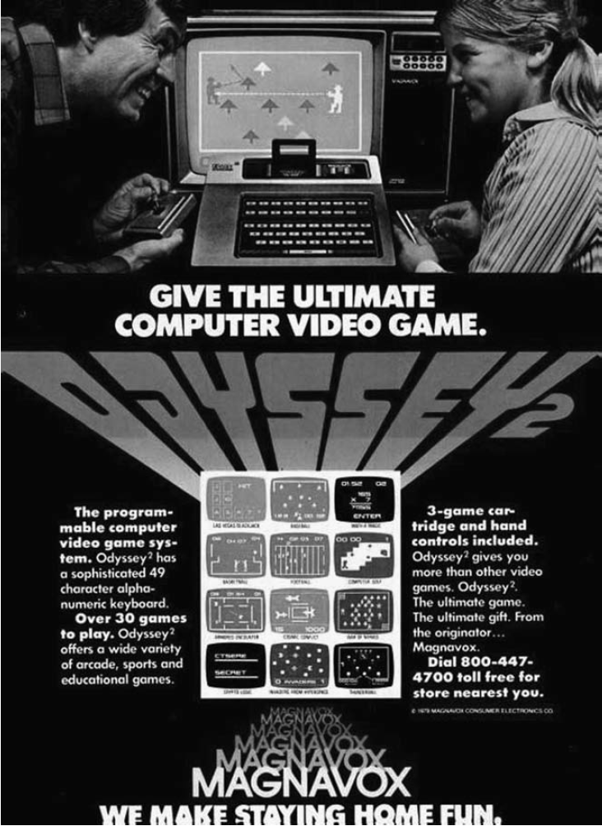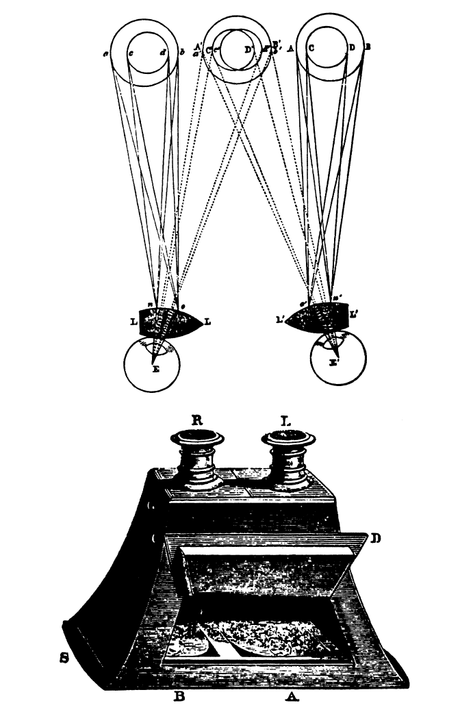

Required Readings

Jonathan Crary, “Techniques of the Observer”, October, vol. 45, (Summer 1988): pp. 3-35.

Erkki Huhtamo, “What’s Victoria Got To Do with It: Towards an Archaeology of Domestic Video Gaming,” in Before the Crash: Early Video Game History, ed. Mark J. P. Wolf, (Detroit: Wayne State University Press, 2012), pp. 30-52.

Secondary Sources

Erkki Huhtamo, “Slots of Fun, Slots of Trouble: An Archaeology of Arcade Gaming,” in Handbook of Computer Game Studies, eds. Joost Raessens and Jeffrey Goldstein, (Cambridge, MA: MIT Press, 2005), pp. 3-21.

Claus Pias, “The Game Player’s Duty: The User as the Gestalt of Ports”, in Media Archaeology: Approaches, Applications, and Implications, (Berkeley: University of California Press, 2011), pp. 164-183.

Primary Sources

Museum of the Moving Image, Queens, NY, Online Collections; Eastman House, Rochester, NY. Online Collections; The Richard Blazer Collection; Online collections.
WEEK 3 // September 21 // Inventing Usability //

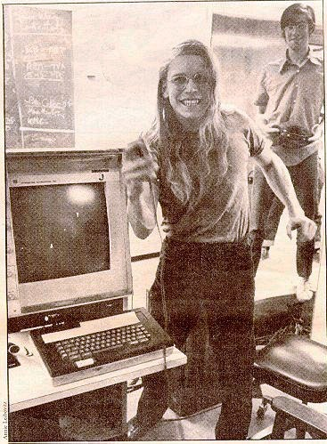

Required Readings

Henry Lowood, “Videogames in Computer Space: The Complex History of Pong”, IEEE Annals of the History of Computing, (July-September 2009), pp. 5-19.

Fred Turner, “Introduction” and “Taking the Whole Earth Digital,” chapter 4 from, From Counterculture to Cyberculture: Stewart Brand, the Whole Earth Network, and the Rise of Digital Utopianism, (Chicago: University of Chicago Press, 2006), pp. 1-9, 103-140.

Primary Sources

Steve Russell, et al. Spacewar!, 1962. PDP-1. Emulated in MESS/MAME. Internet Archive: https://archive.org/details/pdp1_spacewar

Stewart Brand, “SPACEWAR: Fanatic Life and Symbolic Death Among the Computer Bums”, Rolling Stone, (7 December 1972).

Stewart Brand, ed. The Whole Earth Catalogue, (self-published, 1968).

Douglas Engelbart, “The Mother of All Demos”, 1968. YouTube. https://www.youtube.com/watch?v=yJDv-zdhzMY

WEEK 4 // September 28 // Video Land //

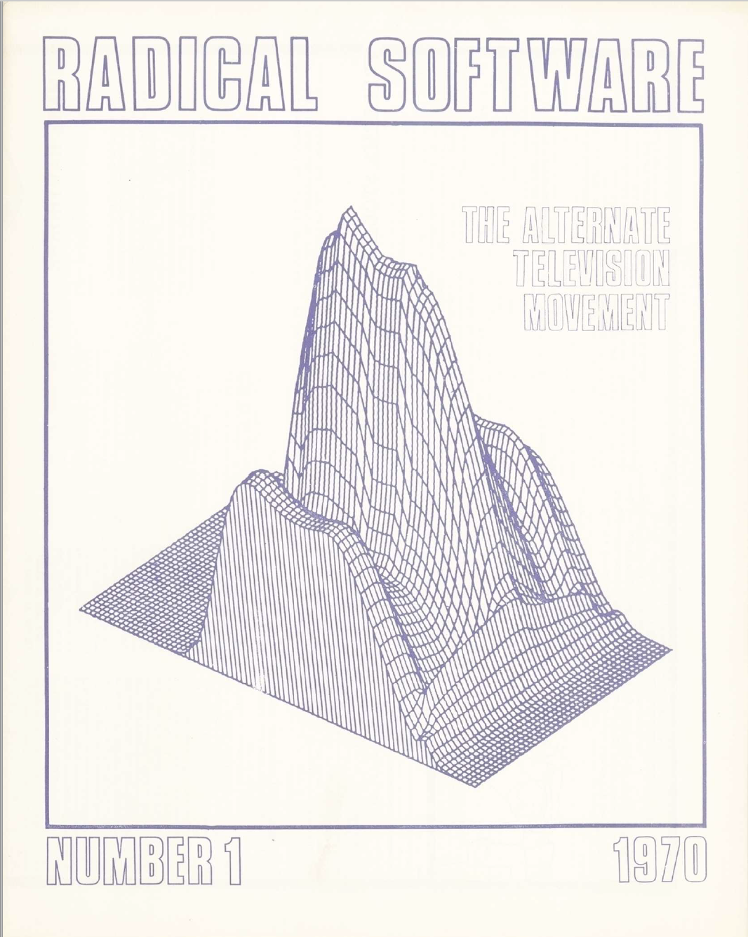

Required Readings

Jason Wilson, “Participation TV: Video Archaeology and New Media Art,” in The Pleasures of Computer Gaming: Essays on Cultural History, Theory, and Aesthetics, eds. Melanie Swalwell and Jason Wilson, (Jefferson, NC: McFarland, 2008), pp. 94-117.

Nick Montfort and Ian Bogost, “Random and Raster: Display Technologies and the Development of Videogames”, IEEE Annal of the History of Computing, vol. 31, no. 3 (July-September 2009), pp. 34-43.

Secondary Sources

Michael Z. Newman, “Video as Alternative”, chapter 3 from, Video Revolutions: On the History of a Medium, (New York: Columbia University Press, 2014), pp. 19-71.

Primary Sources

For an easy-to-use Atari 2600 emulator, see: http://openemu.org/ .Or for an in-browser, accurate Atari 2600 emulation, including Yar’s Revenge, see http://www.virtualatari.org/

RadicalSoftware.org is a complete online archive of the Radical Software journal: an important print venue for 1970s alternative television: http://www.radicalsoftware.org/

WEEK 5 // October 5 // BBS, MUD, MOO //

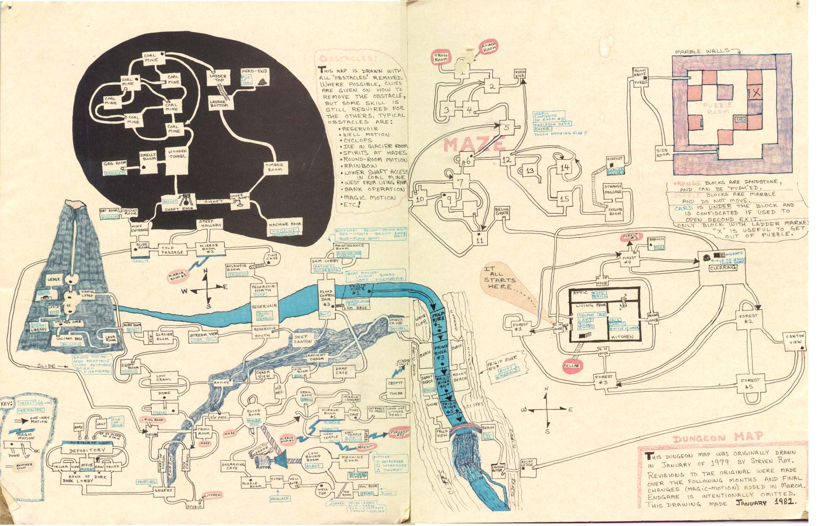

Required Readings

Janet H. Murray, “Introduction: A Book Lover Longs for Cyberdrama” and “From Additive to Expressive Form”, intro and chapter 3 from, Hamlet on the Holodeck: The Future of Narrative in Cyberspace, (New York: The Free Press, 1997), pp. 1-10, 65-94.

Finn Brunton, “Ready for the Next Message: 1971-1994”, chapter 1 from, Spam: A Shadow History of the Internet, (Cambridge, MA: MIT Press, 2013), pp. 1-62.

Secondary Sources

Laine Nooney, “A Pedestal, A Table, A Love Letter: Archaeologies of Gender in Videogame History”, Gamestudies, vol. 13, iss 2, (December 2013), online.

Sherry Turkle, Life on the Screen: Identity in the Age of the Internet, (New York: Simon and Schuster, 1995).

Primary Sources

Julian Dibbell, “A Rape in Cyberspace: How and Evil Clown, A Hatian Trickster Spirit, Two Wizards, and a Cast of Dozens Turned a Database into a Society”, The Village Voice, (21 December 1993): pp. 36-42.
WEEK 6 // October 12 // Global-Local Gaming //

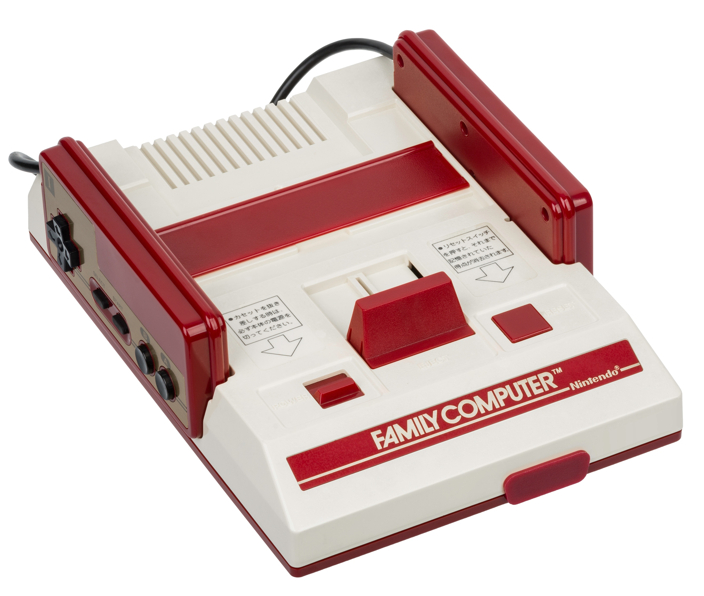

Required Readings

Steinberg, Marc, “Anytime, Anywhere: Tetsuwan Atomu Stickers and the Emergence of Character Merchandizing”, Theory Culture Society, vol. 26, (2009): pp. 113-138.

Martin Picard, “The Foundation of Geemu: A Brief History of Early Japanese Video Games”, Gamestudies, vol. 13, iss 2, (December 2013), http://gamestudies.org/1302/articles/picard

Secondary Sources

Hiroki Azuma, Otaku: Japan’s Database Animals, trans. Jonathan E. Abel and Shion Kono, (Minneapolis: university of Minesota Press, [2001] 2009).

Carly A. Kocurek, “Coin-Drop Capitalism: Economic Lessons from the Video Game Arcade”, in Before the Crash: Early Videogame History, Detroit: Wayne State Press, 2012).

Laine Nooney, “A Pedestal, A Table, A Love Letter: Archaeologies of Gender in Videogame History”, Game Studies, vol. 13, no. 2 (December 2013), online.

WEEK 7 // October 19 // Midterm Exam
WEEK 8 // October 26 // DOOM and MYST

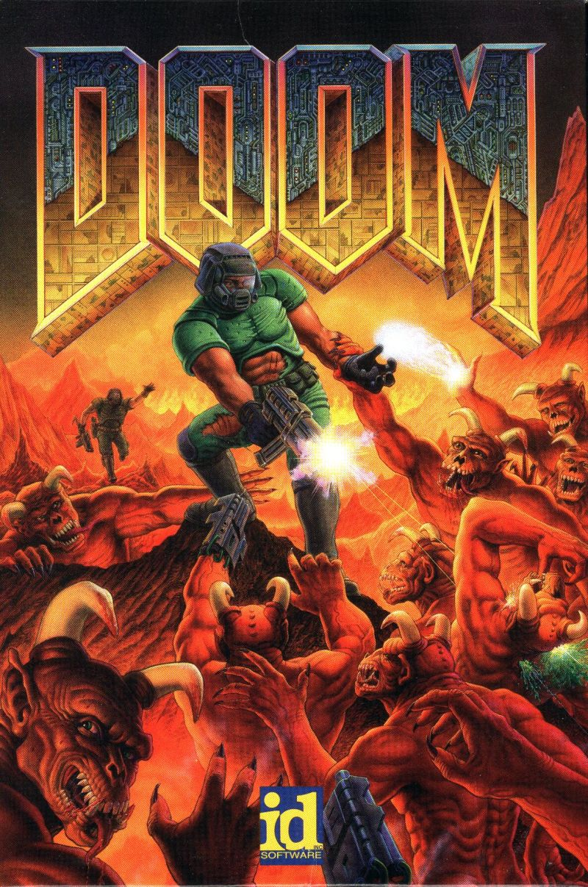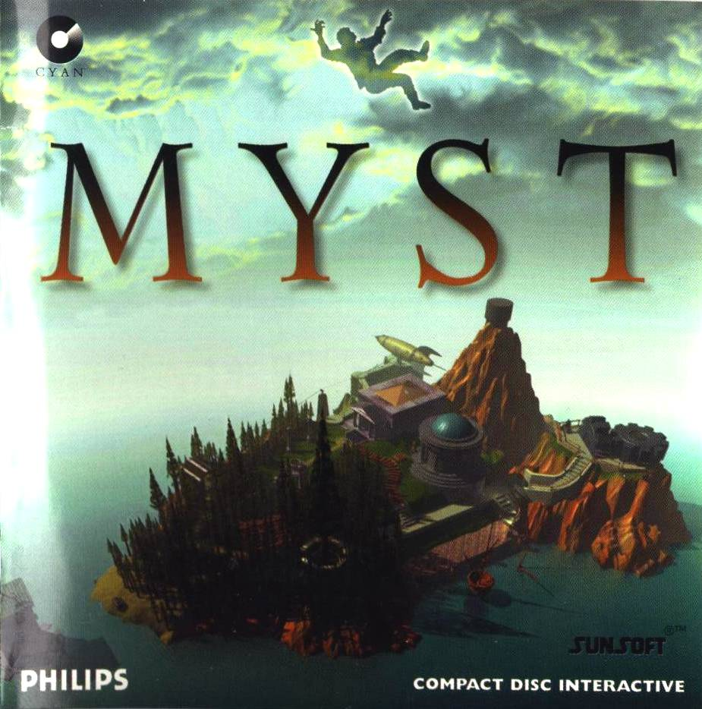

Required Readings

Lev Manovich, “Prologue: Vertov’s Dataset” and “Navigable Space”, chapters from, The Language of New Media, (Cambridge, MA: MIT Press, 2001), pp. xiv-xxxix, 244-285.

Jacob Gaboury, “Hidden Surface Problems: On the Digital Image as Material Object”, Journal of Visual Culture, vol. 14, no. 1 (2015), pp. 41-60.

Secondary Sources

Carl Therrien, “Inspecting Video Games Historiography Through Critical Lens: Etymology of the First-Person Shooter Genre”, Game Studies, vol. 15, no. 2 (December 2015). http://gamestudies.org/1502/articles/therrien

Primary Sources

To play Doom or Myst you can use the DOSBox or Boxer emulators, or play in-browser, here: http://playdosgamesonline.com/

WEEK 9 // November 2 // Net.Art

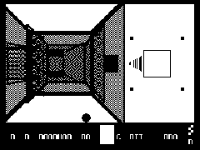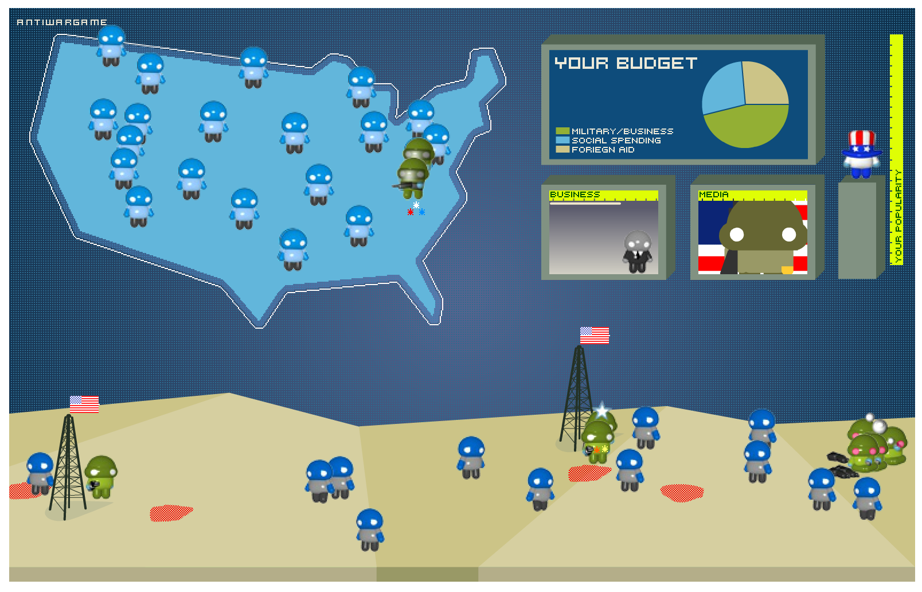

Required Reading

Alexander R. Galloway, “Allegories of Control” and “Countergaming,” chapters from, Gaming: Essays on Algorithmic Culture, (Minneapolis: University of Minnesota Press, 2006).

Secondary Sources

Adriana de Souza e Silva and Jordan Frith, “Introduction” and “From Voice to Location”, chapters from, Mobile Interfaces in Public Spaces: Locational Privacy, Control, and Urban Sociability, (New York: Routledge, 2012) pp. 1-21, 78-108.

Christine Paul, “Internet and Networked Art” and “Gaming”, sections in, Digital Art, 3rd edition, World of Art series, (New York: Thames and Hudson, 2015), pp. 111-124.

Primary Sources

Olia Lialina and Dragan Espenschied, Digital Folklore: To Computer Users, With Love and Respect, (Suttgart: Mertz and Solitude, 2008).

Olia Lialina, My Boyfriend Came Back from the War, 1996. Browser-based, point-and-click interactive fiction. http://www.teleportacia.org/war/

Anne Marie-Schliener, ed. and curator, “Cracking the Maze: Game Plug-ins and Patches as Hacker Art”, Switch, Game-Art issue, vol. 2, no. 5, (1999): http://switch.sjsu.edu/web/v5n2/index2.html

WEEK 10 // November 9 // The Media Mix //

Required Readings

Mizuko Ito, “Technologies of the Childhood Imagination: Yu-Gi-Oh!, Media Mixes, and Everyday Cultural Production”, in Structures of Participation in Digital Culture, ed. Joe Karaganis, (New York: Social Science Research Council, 2007), pp. 89-110.

Lisa Nakamura, “‘Ramadan Is Almost Here!’ The Visual Culture of AIM Buddies, Race, Gender, and Nation on the Internet,” chapter 1 from, Digitizing Race: Visual Cultures of the Internet, (Minneapolis: University of Minnesota Press, 2008), pp. 37-69.

Secondary Sources

Tomoyuki Okada, “Youth Culture and the Shaping of Japanese Mobile Media: Personalization and the Keitai Internet as Multimedia”, in Personal, Portable, Pedestrian: Mobile Phones in Japanese Life, eds. Mizuko Ito, Misa Matsuda, and Diasuke Okabe, (Cambridge, MA: MIT Press, 2006), pp. 41-60.

Michael Bull, Sound Moves: iPod Culture and Urban Experience, (New York: Routledge, 2007).

WEEK 11 // November 16 // Edutainment // Paper Proposals Due

Required Readings

Mizuko Ito, “Academics”, chapter in Engineering Play: A Cultural History of Children’s Software, (Cambridge, MA: MIT Press, 2009).

Joy Rankin, “From the Mainframes to the Masses: A Participatory Computing Movement in Minnesota Education”, Information & Culture: A Journal of History, vol. 50, no. 2 (2015), pp. 197-216.

Secondary Sources

Douglas D. Nobel, The Classroom Arsenal: Military Research, Information Technology, and Public Education, (New York: The Falmer Press, 1991).

Amy F. Ogata, Designing the Creative Child: Playthings and Places in Midcentury America, Minneapolis: University of Minnesota Press, 2013).

Primary Sources

David H. Ahl, ed. Creative Computing, Computer Literacy Issue, vol. 1, no. 5, (September-October 1975).

Stewart Cheifet and Herb Lechner, hosts, “Computers in Education”, The Computer Chronicles, (San Mateo, CA: KCSM TV, 1983). Television Broadcast.

WEEK 12 // November 23 // Thanksgiving // NO CLASS

WEEK 13 // November 30 // Casual vs. Hardcore

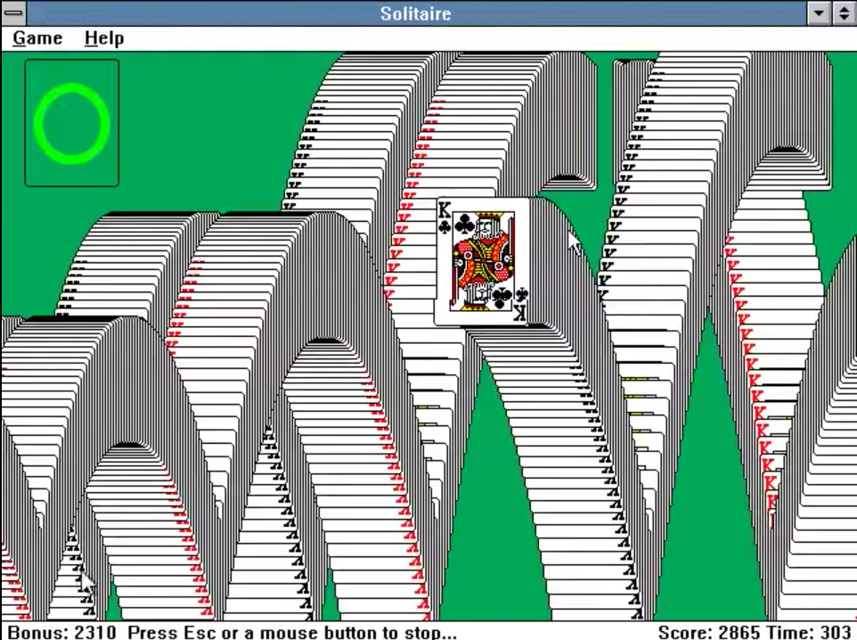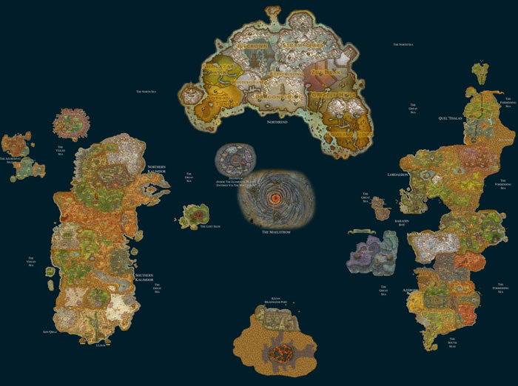

Required Readings

Jesper Juul, “A Casual Revolution”, “All the Games You Played Before”, and “Innovations and Clones”, intro and chapters 3 and 4 from, A Casual Revolution: Reinventing Video Games and Their Players, (Cambridge, MA: MIT Press, 2010), pp. 1-20, 66-101.

Shaka McGlotten, “Intimacies in the Multi(player)verse”, chapter 3 from, Virtual Intimacies: Media, Affect, and Queer Sociality, (New York: Suny Press, 2013), pp. 39-60.

Secondary Sources

Lisa Gitelman, “Xerographers of the Mind”, chapter 3 from, Paper Knowledge: Toward a Media History of Documents, (Durham: Duke University Press, 2014).

Bryan G. Berenshausen, “Toward a (Kin)Aesthetic of Video Gaming: The Case of Dance Dance Revolution”, Games and Culture, vol. 2, no. 4, (2007): pp. 335-345.

Primary Sources

Myron Kruger, “‘VIDEOPLACE’: A Report from the ARTIFICIAL REALITY Laboratory,” Leonardo, vol. 18, no. 3, (1985), pp. 145-151.

Joel Garreau, “Office Minefield: Computers Make Work A Lot Easier. They Make Play Easier Too,” The Washington Post, (9 March 1994): pp. C1, C9.

You can play Solitaire and Minesweeper for Windows 3.0 here: http://playdosgamesonline.com/

WEEK 14 // December 7 // Addiction and Prediction //

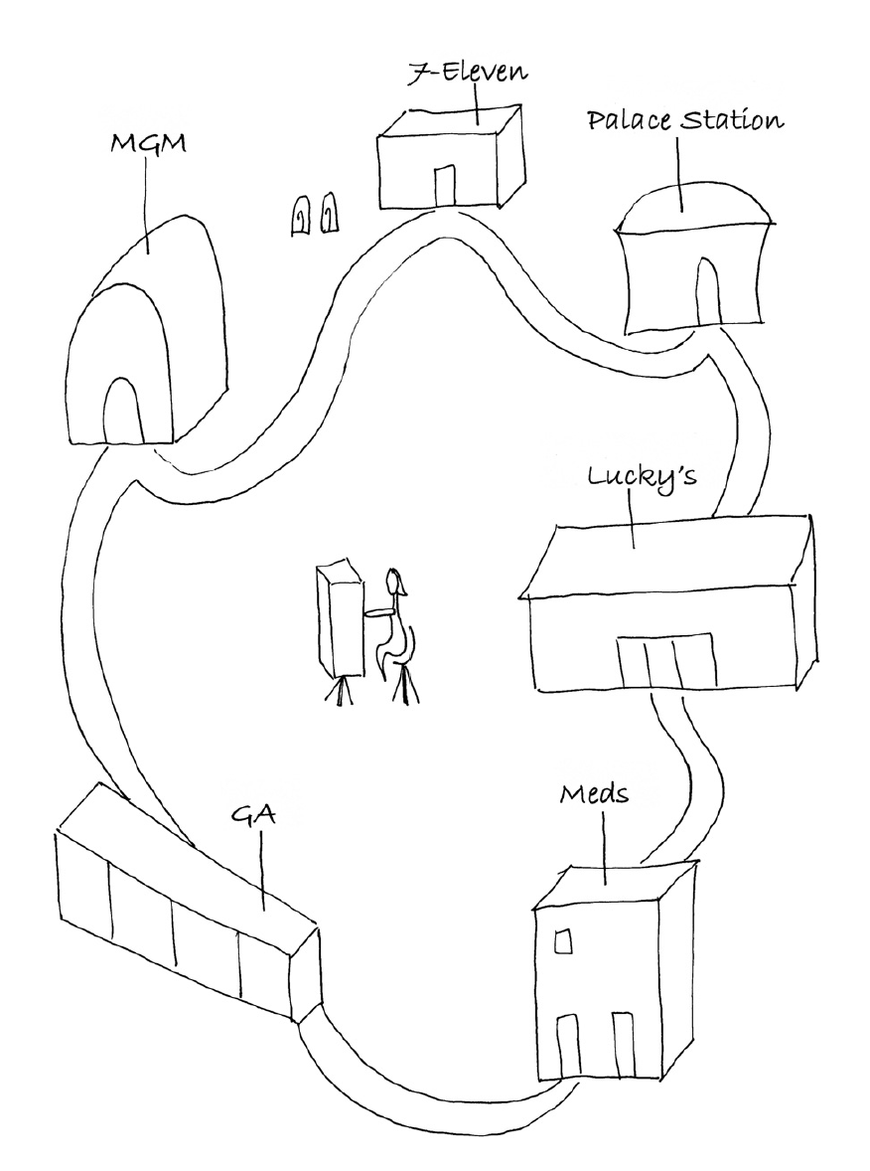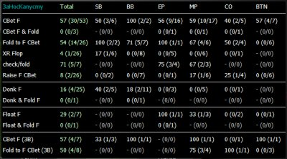

Required Readings

Natasha Döw Schull, “Mapping the Machine Zone” and “Gambled Away”, in Addiction by Design: Machine Gambling in Las Vegas, (Princeton: Princeton University Press, 2012).

Natasha Döw Schull, “The Gaming of Chance: Online Poker and the Potentialization of Uncertainty”, in Modes of Uncertainty: Anthropological Cases, (Chicago: University of Chicago Press, 2015), pp. 46-66.

Primary Sources

Clifford Geertz, “Deep Play: Notes on the Balinese Cockfight”, Daedalus, vol. 134, no. 4, (Fall 2005 [reprint of Daedalus, Winter 1972]), pp. 56-86.

Roger Caillois, Man, Play, and Games, trans. Meyer Barash, (Urbana, IL: University of Illinois, [1958] 2001).

Johan Huzinga, “The Nature and Significance of Play as a Cultural Phenomenon”, chapter 1 from, Homo Ludens: A Study of the Play-Element in Culture, (New York: Routledge, 1949), pp. 1-27.

WEEK 15 // December 14 // The New Videogames // Final Paper Due

Required Reading

Anna Anthropy, “The Problem with Videogames,” “Changing the Game,” and “The New Videogame,” chapters from, Rise of the Videogame Zinesters: How Freaks, Normals, Amateurs, Artists, Dreamers, Dropouts, Queers, Housewives, and People Like You Are Taking Back an Art Form, (New York: Seven Stories Press, 2012), pp. 1-21, 69-115.

Secondary Sources

Ian Bogost, “Procedural Rhetoric”, chapter 1 from, Persuasive Games: The Expressive Power of Videogames, (Cambridge, MA: MIT Press, 2007), pp. 1-64.

Primary Sources

Merritt Kopas, ed. Videogames for Humans: Twine Authors in Conversation, (Instar Books)

Molleindustria’s games are available for free online: http://www.molleindustria.org/
Anna Anthropy’s games are modestly priced (or free) at: https://w.itch.io/

Other influential indie titles include:
Cardboard Computer, Kentucky Rout Zero, PC, OSX, 2013-2016. http://kentuckyroutezero.com/
Jonathan Blow, Braid, PC, OSX, Xbox, 2008-2010. http://braid-game.com/
Fullbright, Gone Home, PC, OSX, Playstation4, Xbox, 2013. http://gonehome.game/
Tale of Tales, Luxuria Suburbia, iOS, Android, 2013. http://tale-of-tales.com/WEEK 15 //

